Hypothesis Verification and Statistical Analysis
- Hypothesis 1: Data Size Scaling Verification
Table 1: Paired t-Test Results and Commitment Verification across Data Sizes

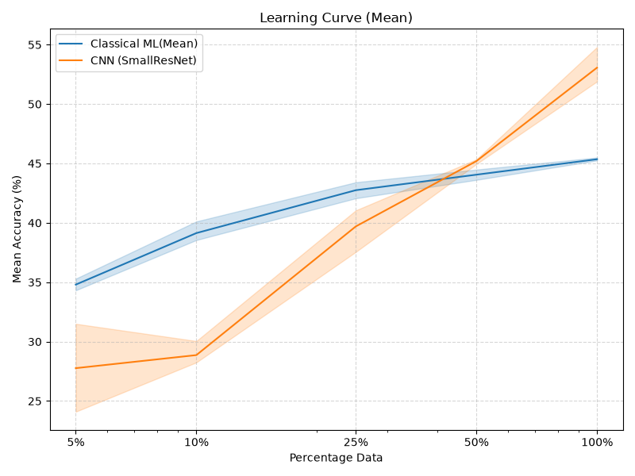 | 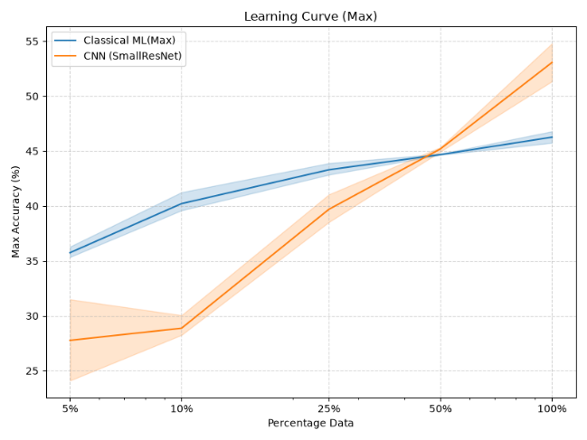

Evaluation of Hypothesis 1: Based on the quantitative falsification criteria established prior to experimentation, Hypothesis 1 is rejected:
- Low-data regime ($≤30\%$): Classical ML and CNN were hypothesized to show comparable performance with differences $≤5\%$. However, empirical observations demonstrate that traditional ML significantly outperforms CNN in sparse data regimes: by $+7.03\%$ at $5\%$ data, and by $+10.27\%$ at $10\%$ data ($t=10.65,p=0.0087$). Both conditions violate the predefined $≤5\%$ tolerance threshold.

- High-data regime ($>30\%$): CNN achieves a statistically significant performance advantage over classical ML only at $100\%$ data scale ($t=-7.35,p=0.018$, outperforming ML by $7.71\%$).

- Conclusion: The initial deficit of CNN is not an artifact of training variance, but highlights the inductive bias requirement of convolutional architectures where minimal data thresholds are needed to surpass feature engineering.

- Hypothesis 2: Noise Robustness and Degradation Verification
Table 2: Overall Degradation Slope Paired t-Test (at 100% Data)

Table 3: Multi-Interval Relative Accuracy Drop Analysis
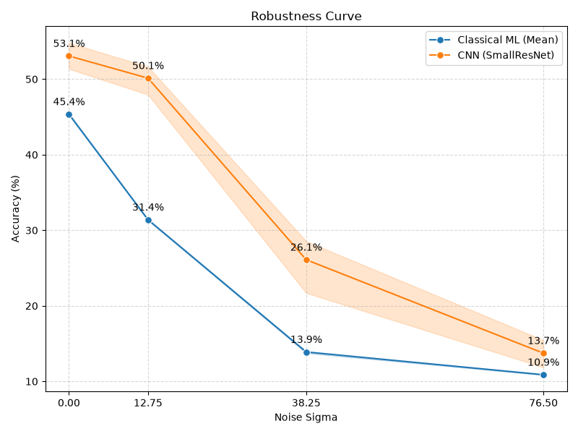

Evaluation of Hypothesis 2 & Robustness Paradox: The experimental results reveal an apparent contradiction between the aggregate slope metric and segment-wise degradation behavior, ultimately disproving the core mechanistic premise of Hypothesis 2:
- Aggregate degradation slope ($0→76.5$): The paired t-test indicates a higher overall slope for CNN ($0.5142$) compared to classical ML ($0.4508$) with $t=-66.76,p=0.0002$.

- Segment-wise analysis (The Low-Noise Paradox): The original hypothesis assumed that multi-layer CNNs would degrade faster due to layer-wise error propagation and amplification. Segment-wise data explicitly refutes this assumption:
    - Under mild noise ($σ=0→12.75$), traditional ML suffers a relative performance drop of $31.53\%$, whereas CNN only drops by $5.65\%$. CNN is over five times more resilient to low-level noise.

    - The larger overall slope observed for CNN is a mathematical artifact of its higher initial baseline ceiling ($53.07\%$ vs. $45.36\%$). ML collapses immediately in the first interval and bottoms out near random guessing, whereas CNN degrades steadily across all noise levels.

- Conclusion: Classical ML is structurally fragile even to slight perturbations, whereas convolutional filters serve as local spatial smoothers against Gaussian noise.
- Summary of Hypothesis Outcomes
- Hypothesis 1: Rejected. Classical ML significantly outperforms CNN under sparse training regimes ($≤10\%$ data), violating the $5\%$ margin condition.
- Hypothesis 2: Rejected. Classical ML experiences rapid performance collapse under mild noise, refuting the assumption that multi-layer CNN architectures amplify noise faster than single-layer ML models.

